**Quality Review:** GotoGro-MRM

**Quality Test Execution**

As per the plan in 72D, a survey was created and undertaken by the group team members as well as some external colleagues. Each person taking the survey was briefed that they should use the report generating feature pretending as if they were a shift manager. This way the data gathered for the question about information relevancy would be slightly more reasonable then if they were left to do it without any explanation.

**Table 1** summarises the results while **Figures 1-5** show screenshots of the raw responses from survey monkey:

**Table 1. Summarised Results**

|  |  |  |  |  |  |  |  |  |
| --- | --- | --- | --- | --- | --- | --- | --- | --- |
| **Question** |  |  |  |  |  |  |  | **Average** |
| Using any number from 0 to 10, where 0 is extremely difficult and 10 is extremely easy, how easy was it to generate a report from the interface? | 10 | 9 | 10 | 10 | 10 | 9 | 10 | 9.7 |
| Using any number from 0 to 10, where 0 is extremely unsuitable and 10 is extremely suitable, how suitable was the information provided on the default report to your needs? | 8 | 8 | 10 | 9 | 9 | 8 | 8 | 8.6 |
| Using any number from 0 to 10, where 0 is extremely difficult and 10 is extremely easy, how easy was it to change the report type? | 9 | 10 | 10 | 8 | 8 | 10 | 8 | 9 |
| Did the default report contain all the information you were looking for (yes/no)? | Yes | Yes | Yes | Yes | Yes | Yes | Yes | - |
| If you answered no to Q4, what was missing? | - | - | - | - | - | - | - | - |

According to the data each question has an average sentiment response of greater than 7. This means that the component has achieved its quality metrics as specified in 71D. The question with the highest average response is question 1 with 9.6 indicating that it was extremely simple to generate the report after navigating to the page. The question with the lowest score was question 2 with 8.6, which could be lower for a number of reasons.

First, and as mentioned, question 2 is highly subjective to the operators needs as it asks whether the reports meet their requirements in reference to a shift managers job of checking inventory and sales reporting. Without actual sales reps to report this on we had to use people who were familiar with the kind of things managers may be looking for – retail workers, team members, etc. With this in mind, psychology indicates that when people don’t have a perfectly clear idea of what the question is asking, or a strong opinion, they tend to answer neutral-positive. This is most likely what led to the slightly lowered score here.

Contrastingly, the other questions which ask specific questions such as how easy it was to use the tool, can basically be translated as how easy it was to find the buttons on the screen. This is much simpler for anyone to answer, even someone with no experience, so here the results are a lot more decisive – and by extension, probably more accurate. Personally, the button placement is clear and simple as it only requires one click, furthermore, something that the users commented on was that the report preview screen made it even easier to see what they were getting before they clicked and this contributed to heightened scores.

The question pertaining to how easy it was to switch between report types differed from person to person. Again, we opted for a single toggle button which flips between the two report types on each click. For some users they found this ideal, whereas others found it a little confusing as to which one they were looking at as the button name indicates the current report and not the one it *would* take you to if you clicked it. This was a minor thing overall as all the participants found it with no trouble, it was just a slight inconvenience.

There is no strong justification for changing this feature as the feedback is still largely positive, however the idea was suggested to make it two separate buttons but next to each other, preserving readability and layout but making it slightly clearer what button takes you where.

As a final note, question 4 posed a yes or no expanding upon question 2 asking whether or not the participants thought the reports needed more data, which led on to question 5 asking what exactly it needed. Unfortunately, none of the participants answered no, which could be a good thing, but means there is little to go off in terms of further improvement.

The reason for the lack of targeted feedback is directly linked to the discussion about question 2 being difficult to answer when not in a “real-world” setting. That said, the answer shouldn’t be completely disregarded: It is still reasonable to assume that the reports have no glaring gaps in information as more than half the participants have direct experience looking at inventory and sales reports in a retail environment and would have pointed it out if there was a distinct lack of information.

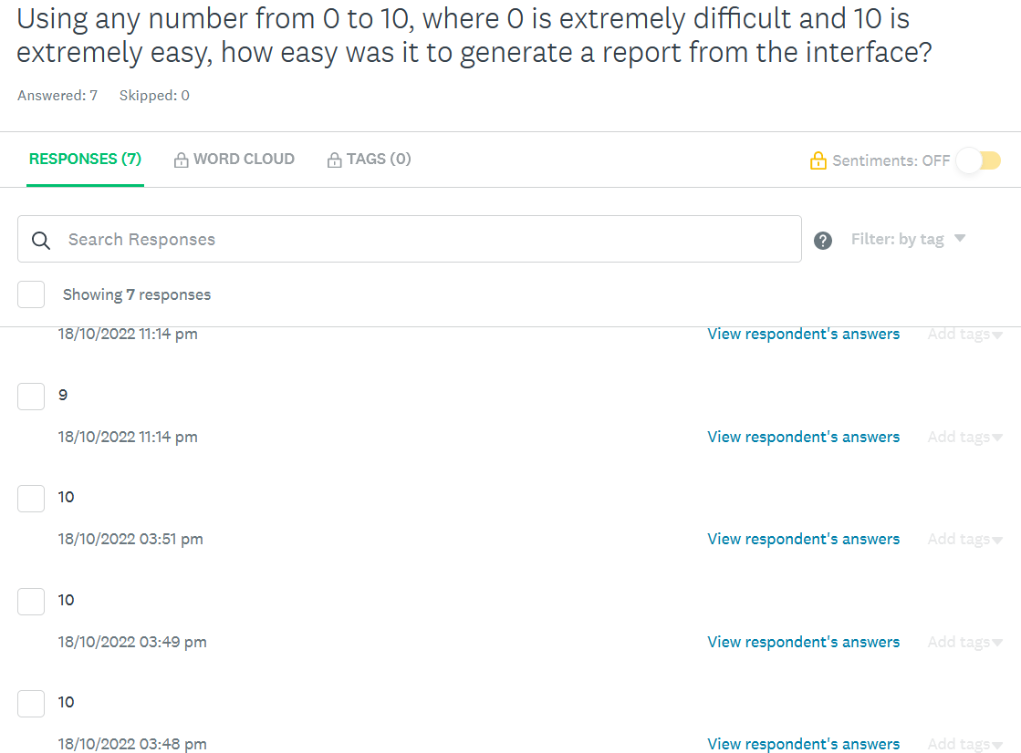Figure 1:*** *Question 1 responses on Survey Monkey.*

***Figure 2:*** *Question 2 responses on Survey Monkey.*

***Figure 3:*** *Question 3 responses on Survey Monkey.*

***Figure 4:*** *Question 4 responses on Survey Monkey.*

***Figure 5:*** *Question 5 responses on Survey Monkey.*